**Experiment 6**

**Aim:** Write a Shell script to sort numbers & alphabetical words in ascending/descending order

**Software:** Ubuntu

**Procedure:**

* Using command #gedit create a file with .sh extension
* Enter the random number or words in the Shell Script
* Use ls command to list out all the files in a directory.
* Use commands #chmod +x filename.sh to give execution rights to the file.
* Then use command #sort -nf for sorting in ascending order.
* And #sort -nr to sort in descending order.

**Output:**

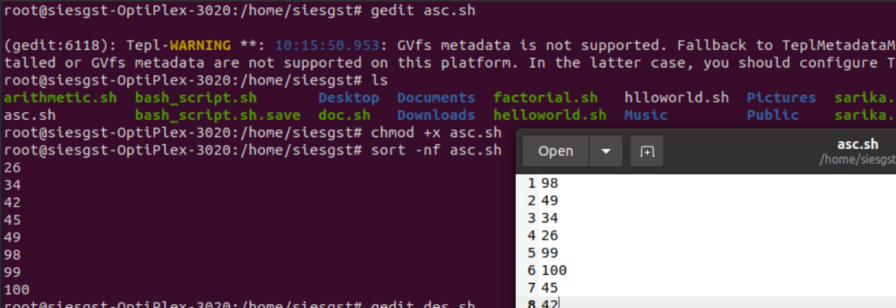

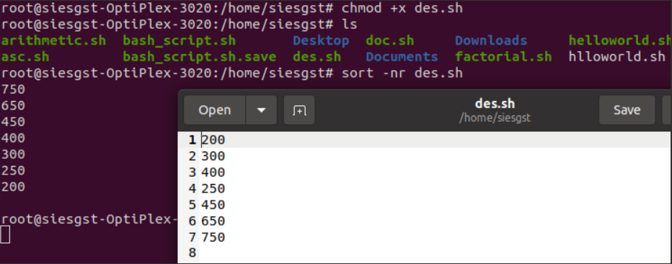

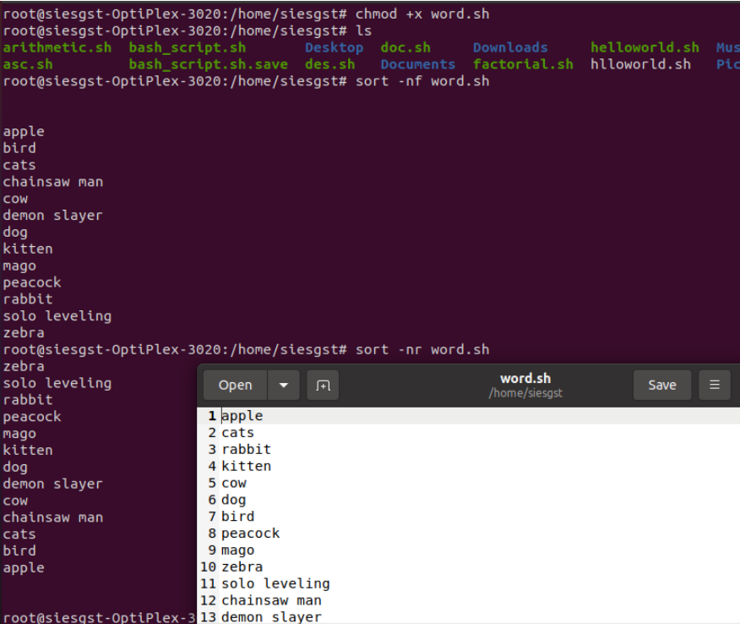

**Conclusion:**

Successfully created a shell script to sort numbers & alphabetical words in ascending/descending order, this can save time and ensure consistency on a Linux system.